
6.3 Periodic Trends
IDX G9 Chemistry S STUDY GUIDE ISSUE 7
By Emma and Gorden

- Many properties of the elements change in a predictable way as you move through the period table, and these systematic variations are called periodic trends
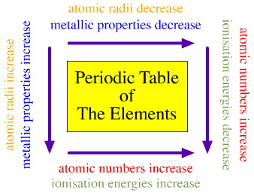
I. Trends in Atomic Size
- The atomic radius is one-half of the distance between the nuclei of two atoms of the same element when the atoms are joined
- The atomic radius is often measured in picometers (pm).
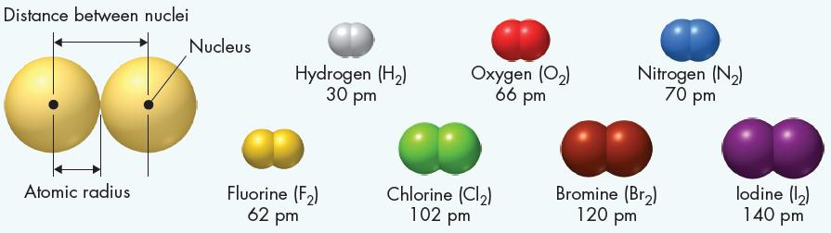
- The attraction force between electrons and nucleus will affect many atom’s properties
- For outmost electrons in principle energy level with quantum number n, the attraction will decrease as n increases.
eg: Li > Na > K > Rb > Cs (group 1)
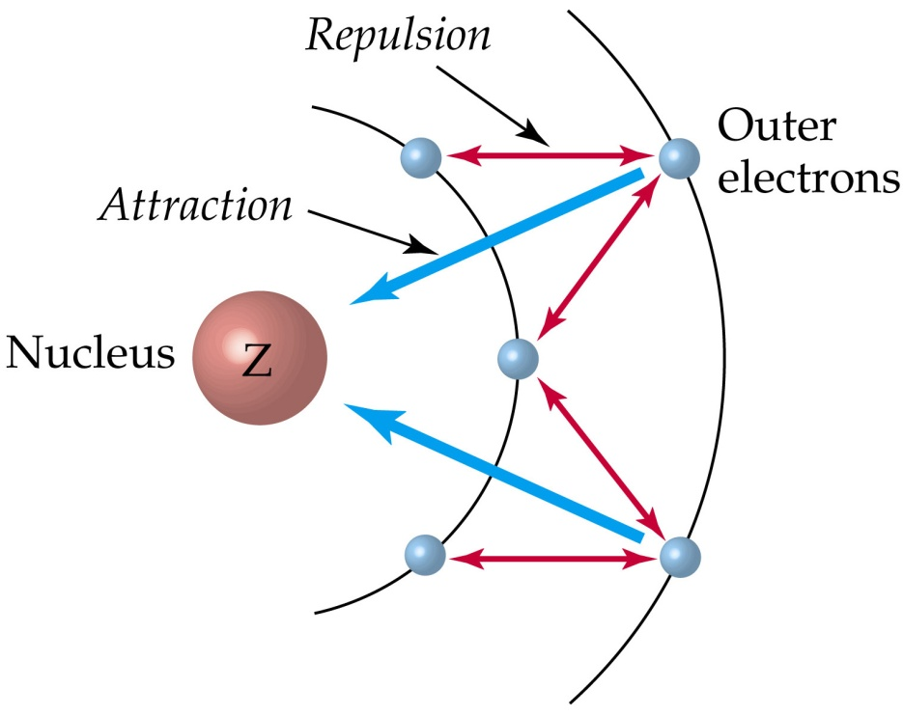
2) If the outmost electrons are in the same principle energy level, the attraction will increase as proton number increases.
eg: Na < Mg < Al < Si < P < S < Cl (period 3)
- Trend 1: Atoms get larger going down a group.
- Going down a group = more energy levels, attraction decrease = outmost electrons go further, size increase
- Trend 2: Atoms get smaller moving from left to right across each period.
- Moving from left to right = same energy level, more protons, attraction increase = outmost electrons closer, atom size decrease
II. Trend for Ionic Size
- An ion is an atom or group of atoms that has a positive or negative charge
- An ion with a positive charge is called a cation (metal easy to lose electrons)
- An ion with a negative charge is called an anion (nonmetal easy to gain electron)
- Octet rule: Atoms tend to gain, lose, or share electrons in order to acquire a full set of valence electrons
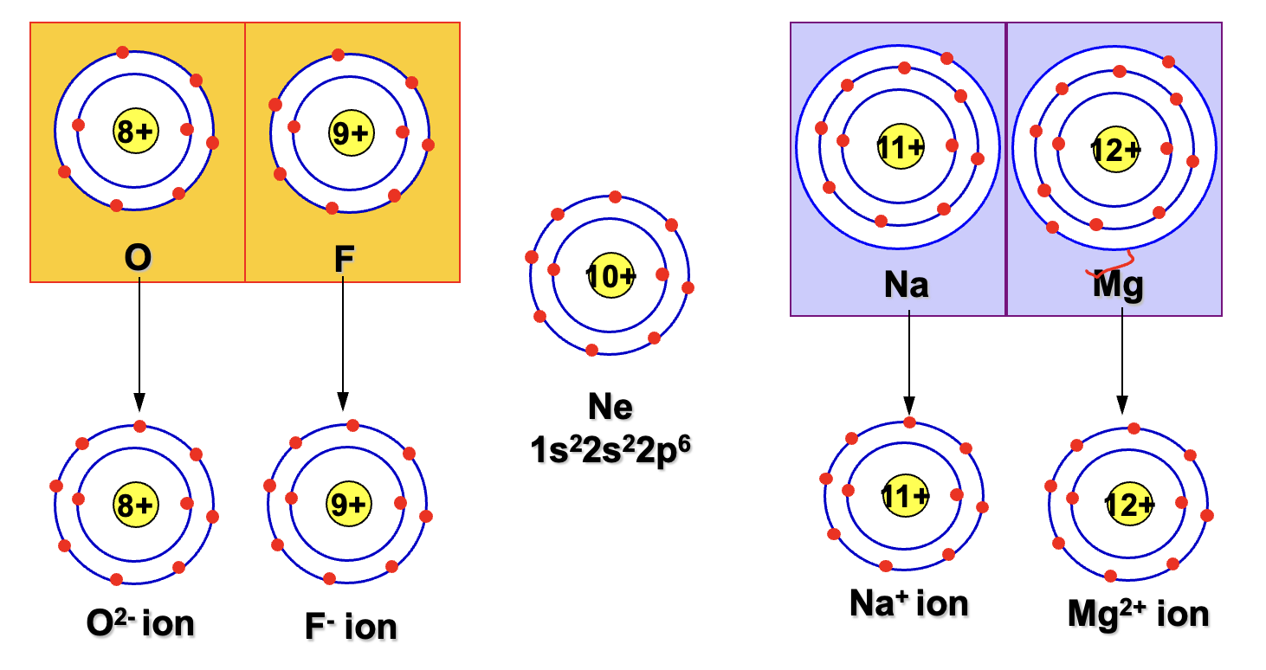
- For most energy levels, there are 8 valence electrons in a full set of valence electrons --- 2 in s orbital and 6 in p orbitals
- An exception for the first energy level, which is full with only 2 electrons
- The elements on the right side of the periodic table tend to gain electrons – or become anions – in order to acquire a complete set of valence electrons (being stable)
- The elements on the left side of the periodic table tend to lose electrons – or become cations – in order to acquire a complete set of valence electrons (being stable)
- Noble gases neither gain nor lose electrons
- Positive Ions (lose electrons) become smaller, because the repulsion between electrons is reduced, radius of a cation is smaller than an atom
- Negative Ions (gain electrons) become larger, because the repulsion between electrons is increased, radius of an anion is larger than an atom
- Trend 1: Ions get larger going down a group
- Trend 2: Ions get smaller from left to right
- The anions in same period and cation of next period have same number of electrons but proton number is increasing in nucleus, thus the attraction force increases and ion sized decreases
- Trend 3: For same elements, the one with less electrons (more positive or less negative) is smaller

III. Trend for Ionization Energy
- An atom’s ionization energy (I) is the energy needed to remove one of its electrons
- Atoms with high I hold onto their electrons tightly, whereas atoms with low I are more likely to lose outmost electrons
- Trend 1: Ionization energies decreases as you move down a group (more energy level, far away from the nucleus)
- Trend 2: Ionization energies increases as you move from left to right across a period (ions get smaller so nearer to the nucleus so more energy is required to remove electrons)
- Ionization energy trends are exactly opposite of the trends for atomic radius, and radius is inversely proportional to attraction while ionization energy is proportional to attraction
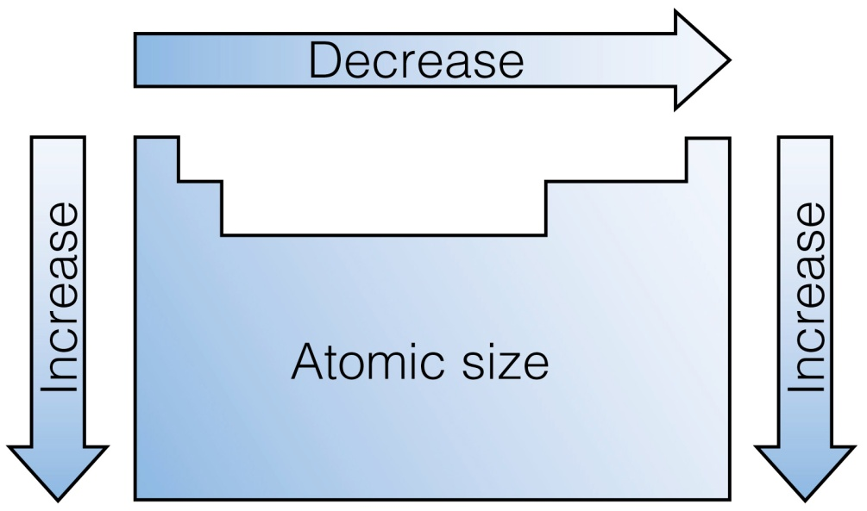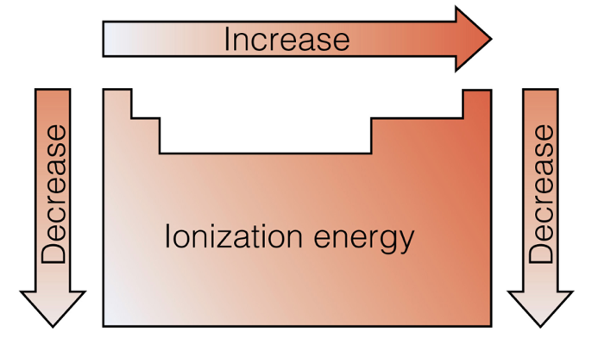
- The successive ionization energies are the energies required to remove electron beyond the first electron
- Trend 3: the ionization energies increase for every electron removed
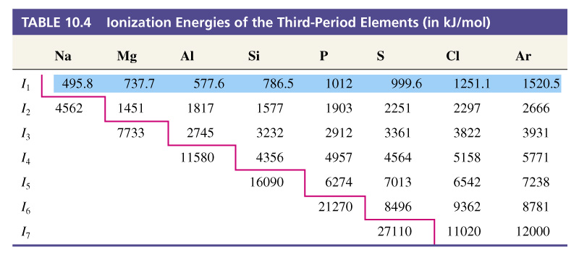
- An atom holds the electrons in its noble gas inner core much more strongly than it holds its valence electrons, so there is a large increase when the atom begins to lose the inner electron
IV. Trend for Electronegativity (EN)
- Electronegativity is the ability of an atom of an element to attract electrons when the atom is in a compound.
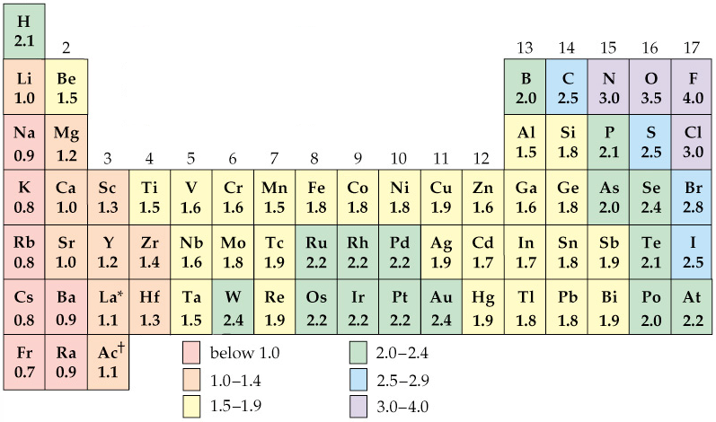
- Electronegativity values have no units and is neither energy ro a property that can be directly measured
- Electronegativity: nonmetal > metal

  - Ions
- The forces that link atoms together to form the different kinds of matter are called chemical bonds
I.Valence Electrons
- Valence electrons are the electrons in the highest occupied energy level of an element’s atoms
- Exception: helium have two valence electrons, and other noble gases have eight valence electrons
- To find the number of valence electrons in an atom of a representative element, simply look at its group number
- Electron dot structures are diagrams that show valence electrons in the atoms of an element as dots
- All the electrons with a given group (with the exception of helium have the same number of electron dots in their structures)
- 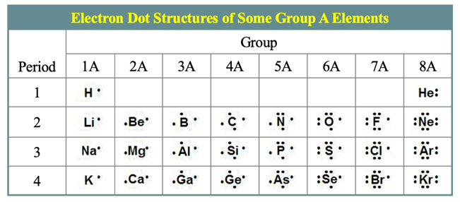
- Electron dot structure will be used to show how chemical bonds form in chemical reaction
II. The Octet Rule
- Noble gases, such as neon and argon, are nonreactive in chemical reactions
- Atoms of each of the noble gases (except helium) have eight electrons in their highest occupied energy levels and the general electron configuration of ns^2np^6
- The octet rule states that in forming compounds, atoms tend to achieve the electron configuration of a noble gas
- Atoms of metal tend to lose their valence electrons, leaving a complete octet in the next-lowest energy level
- Atoms of some nonmetals tend to gain electron or share electrons with another nonmetal atom or atoms to achieve a complete octet
- The octet rule applies to atoms in most compounds
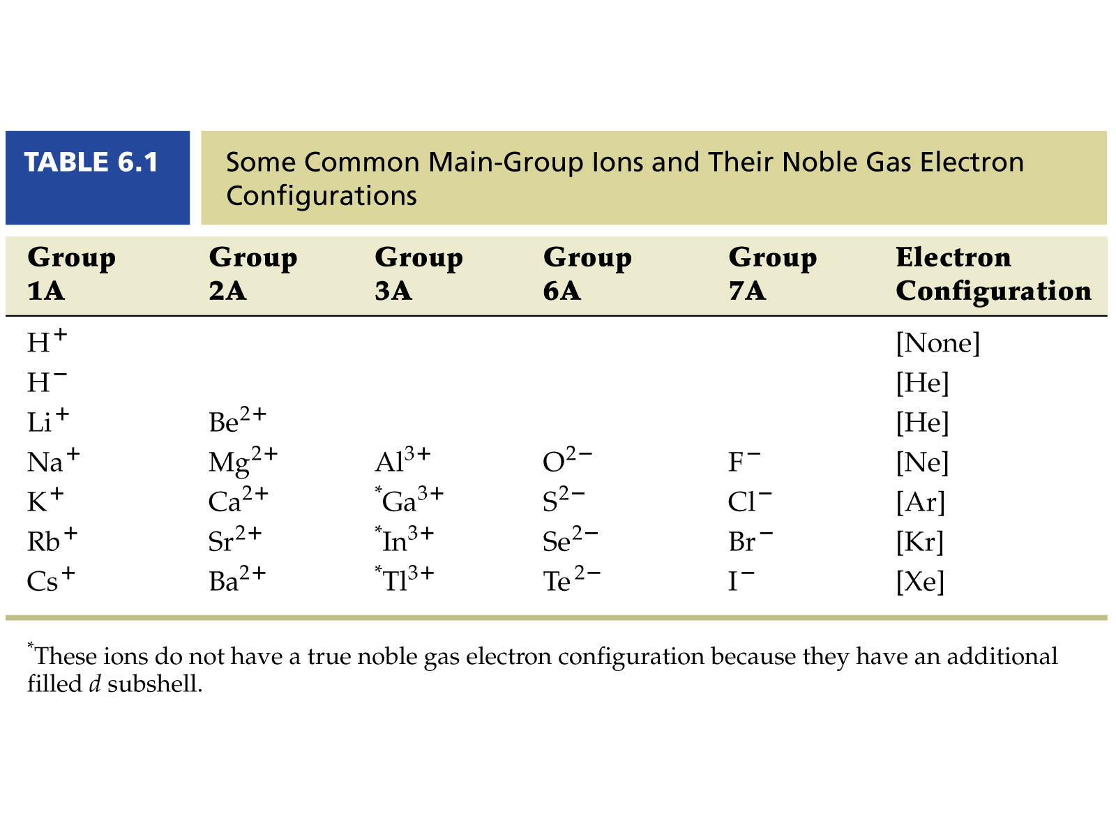
III. Formation of ions
- Ion – an atom that is no longer neutral because it has lost or gained electrons
- A positively charged ion, or cation, is produced when an atom loses one or more valence electrons
- A negatively charged ion, or anion, is produced when an atom gains one or more valence electrons
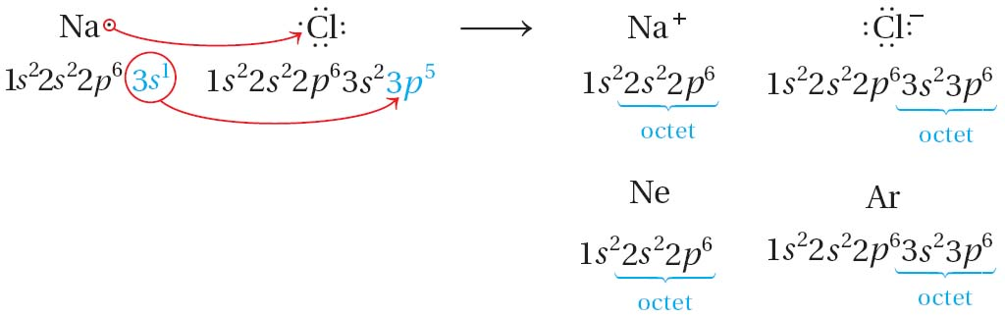
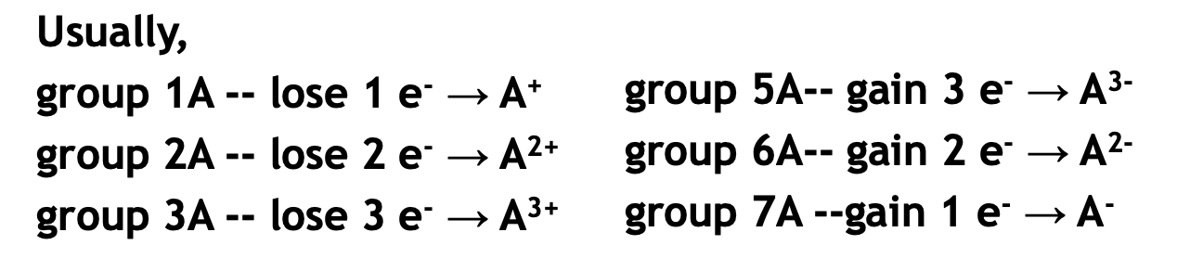
- The name of the anion typically ends in -ide.
- The ions produced when atoms of chlorine and other halogens gain electrons are called halide ions
- Transition Metal Cations
- The charges of cations of the transition metals may vary
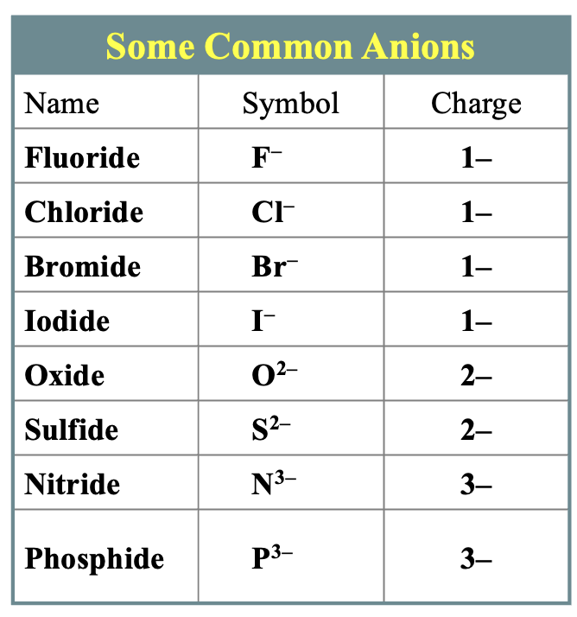

  - Ionic Bonds and Ionic Compounds
- Formation of Ionic Compounds
- An ionic compound is a compound composed of cations and anions
- Although they are composed of ions, ionic compounds are electrically neutral
- If ionic bonds occur between metals and the nonmetal oxygen, oxides form
- Most other ionic compounds are called salts
- Binary ionic compounds contain a metallic cation and a nonmetallic anion
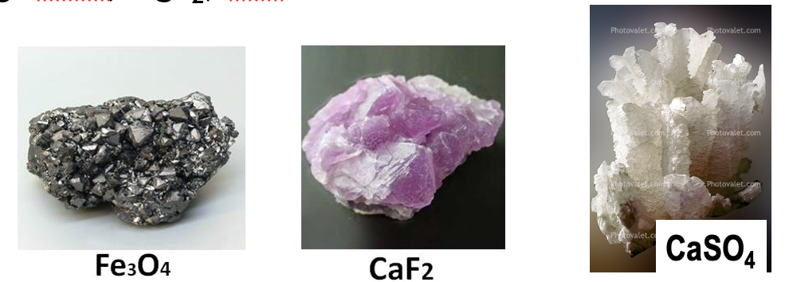
- Ionic compounds are electrically neutral, so the charges of cations and anions must be balance
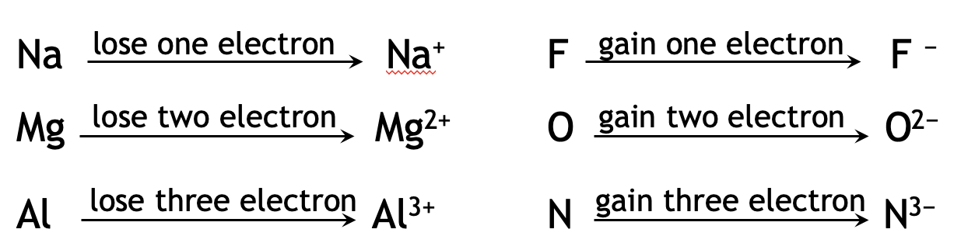
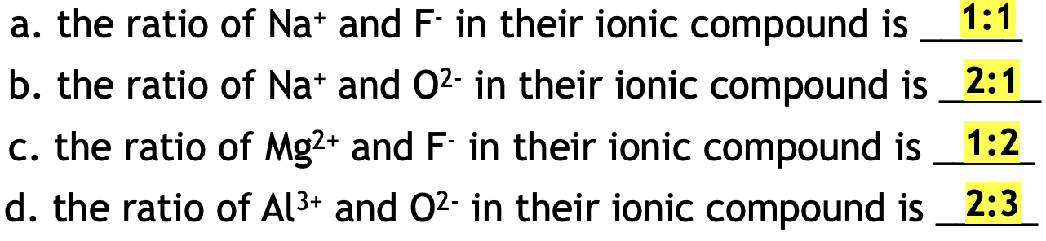
- The electrostatic forces that hold ions together in ionic compounds are called ionic bonds
- A chemical formula shows the numbers of atoms of each element in the smallest representative unit of a substance
- A formula unit is the lowest whole-number ratio of ions in an ionic compound
- For sodium chloride, the lowest whole-number ratio of the ions is 1:1 (one Na+ ion to each Cl- ion)
- Although ionic charges are used to derive the correct formula, they are not shown when you write the formula unit of the compound. The formula unit of sodium chloride is NaCl.

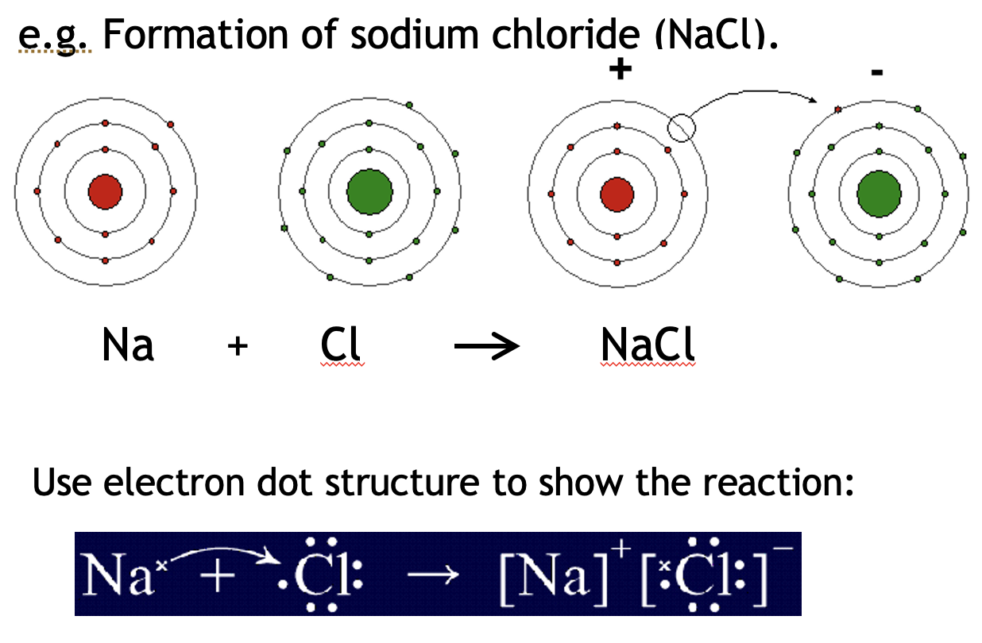
- The coordination number of an ion is the number of ions of opposite charge that surround the ion in a crystal
- In NaCl, each ion has a coordination number of 6.
- The coordination number of Na+ is 6 because each Na+ ion is surrounded by six Cl- ions.
- The coordination number of Cl- is also 6 because each Cl- ion is surrounded by six Na+ ions.
- Properties of ionic compounds
- Most ionic compounds are crystalline solids at room temperature
- The component ions in such crystals are arranged in repeating three-dimensional patterns
- Each ion is attracted strongly to each of its neighbors, and repulsions are minimized
- Property 1: the large attractive forces result in a very stable structure
- Property 2: the network of attractions that extends throughout an ionic crystal gives these compounds their high melting point.
- Property 3: Ionic crystals are strong, but brittle.
- When ionic crystals are struck, the cations and anions are shifted from their fixed positions. Repulsions between ions of like charge cause the crystal to shatter.
- Property 4: Ionic solid is poor conductor. But it can conduct electricity in molten (liquid) state and aqueous state (dissolved in water)
- Ions has fixed position in solid state without freedom to move around
- Ionic compounds can conduct an electric current when melted or dissolved in water.
- When they melted, the orderly crystal structure breaks down. When dissolved, the ions are free to move about in the solution.

  - Bonding in Metals
- Metallic Bonds
- Metals consist of closely packed cations and loosely held valence electrons rather than neutral atoms
- The electron sea model proposes that all the metal atoms in a metallic solid contribute their valence electrons to form a “sea” of electrons
- The electrons in metals that are free to move are referred to as delocalized electrons
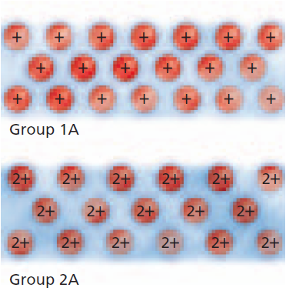
- Metallic bonds are the forces of attraction between the metallic cation for delocalized electrons
- Properties of Metals
- The typical physical properties of metals can be explained by metallic bond
- The properties provide evidence of the strength of metallic bond
- The melting points of metals vary greatly
- Mercury is a liquid at room temperature
- Tungsten has a melting point of 3422 degrees Celsius
- In general, metals have moderately high melting points and high boiling points
- The strength of metallic bonds depend on the charge and size of cations, which affect metallic properties such as melting and boiling points
- Metals are good conductors of heat and electricity
- The mobile valence electrons always have freedom to move to conduct electricity and heat
- Metals are ductile (can be drawn into wires) and malleable (can be hammered or pressed into shapes)
- Two properties: ductility and malleability
- When force is applied to a metal, the electrons shift and thereby keep the metal ions bonded in their new positions
- 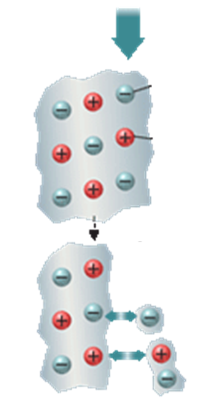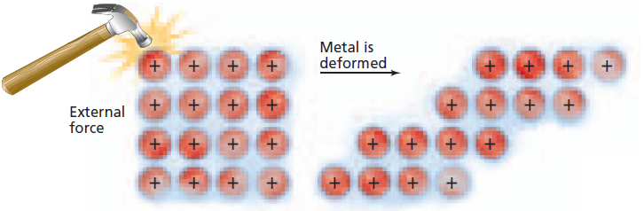
- If an ionic crystal is struck with a hammer, the blow tends to push the positive ions close together
- The positive ions repel one another and the crystal shatters
- Crystaline Structure of Metals
- In a body-centered cubic structure, every atom (except those on surface) has eight neighbors
- Ex. Metallic elements Na, K, Fe, Cr, W
- In a face-centered cubic arrangement, every atom has twelve neighbors
- Ex. Cu, Ag, Au, Al, Pb
- In a hexagonal close-packed arrangement, every atom also has twelve neighbors
- Ex. Mg, Zn, Cd
- Alloy
- Alloys are mixtures of two or more elements, at least one of which is a metal
- Alloys are important because their properties are often superior to those of their component elements
- The most important alloys today are steels
- Steels have a wide range of useful properties, such as corrosion resistance, ductility, hardness, and toughness
- Substitutional alloy – if the atoms of components in an alloy are about the same size, they can replace each other in the crystal
- Ex. Sterling silver, brass, pewter
- Interstitial alloy – if the atomic sizes are quite different, the smaller atoms can fit into the interstices (spaces) between the larger atoms
- Ex. Carbon steel

8.1 The Nature of Covalent Bonding
Covalent Bond: A bond formed when two atoms share one or more pairs of electrons. (commonly occurs between nonmetals or metalloids)

Single Bonds:
Only one pair of electrons are shared.
EX: In H2, each hydrogen atom shares one electron.
Double Bond: a bond that involves two shared pairs of electrons. (EX: CO2).
Triple Bond: I bond that nvolves three shared pairs of electrons (EX: N2).
(Note that those bonds “move” because they have to achieve octet)

How to Draw a Lewis Structure:
Count the total number of valence electrons (including charges).
Connect atoms with a single bond.
Put remaining electrons to complete octets for surrounding atoms.
If there are remainder electrons, place them on the middle atom. If they aren’t complete Octets, form double or triple bonds.

Coordinate Covalent Bonds
Definition: a type of covalent bond where one atom provides both electrons for the shared pair.
Once formed, a coordinate covalent bond is same as a regular covalent bond.
Usually forms when:
One atom already has a lone pair of electrons.
Another atom needs two electrons to complete its octet (EX: H⁺).

Polyatomic ions
It often contain regular covalent bonds and coordinate covalent bonds.

Exceptions
Odd Number of Electrons: NO2 has odd number of electrons and cannot satisfy the octet rule.
Fewer Than an Octet: Some atoms, like boron in BF3 is not a complete an octet. (It has 3 surrounding atoms)
More than an octet: Atoms like SF6 has more than 4 surrounding atoms, thus the central atom (S) has 12 electrons .
Bond Energy
Trends:
Strong covalent bonds = shorter bond lengths.
Multiple bonds (double, triple) are shorter and stronger than single bonds. (Triple shorter than double)

